Please help us, help whole dogs in China… Sharing this news with your friend and post it on each famous news website all over the world… Let all the world know that a country – China which will holding the 2008 Olympic Game, how they treat the dogs. Due to the Olympic Game is coming; the government of China strengthens the management in homeless dogs and restricted dogs.
The definition of restricted dogs in most provinces in China is according to the restricted law in Capital – Beijing. This law restricts the people in Beijing to breed the big dogs, and the definition of big dog means any dogs whose high is more than 35cm. Due to this stupid and non-scientific law, many tameness “big dogs”took away from their home, then sent to dogs prison likes the pictures attached. Most people who had breed dogs all know that how fierce a dog does not relate to its high but its breed. So, using a 35cm restriction to take away the existing right, it is unfair to big dogs. (This prison maybe the best one in China…I can not imagine any others.)
What we want is very simple. Please give dogs the existing right in China, and don’t use the non-scientific restricted law to bereave dogs’ right and life. You can blame their owner for in-civilization activities, but dogs are harmless. I think that it should not be the activities of a country which will host the Olympic Game. Or does this what Olympic Game bring to us?

This is an endless dog prison in China. Do you know how many dogs die here?
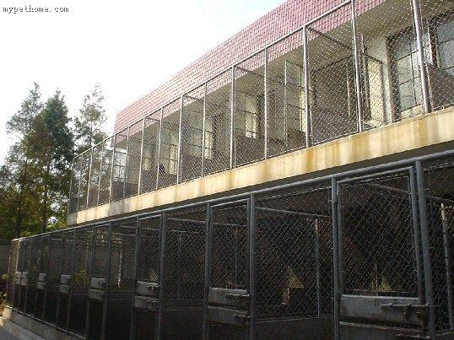

The blood on the side of the door… you never want to know what happened…
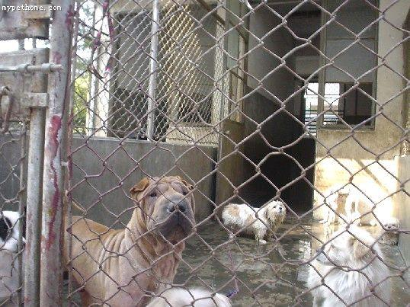

Can you see any happiness in their eye…
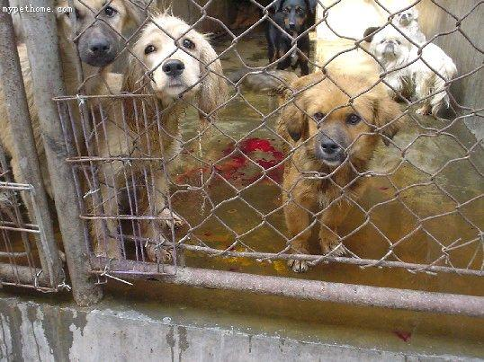
Do we have future… where is our heaven…
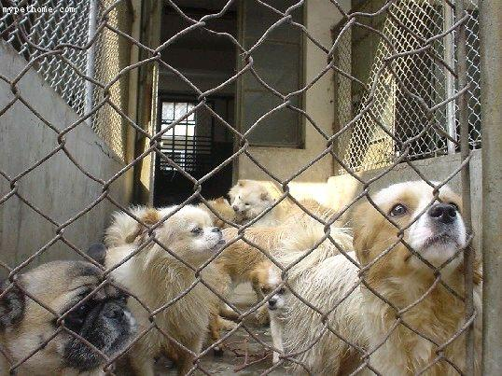

What in their eye is hunger or desperation…
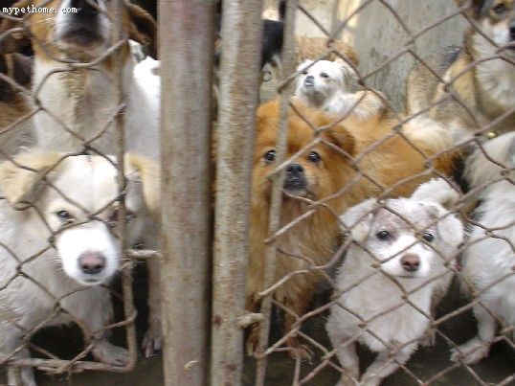
What a beautiful sunlight… but they still tremble… under their feet is disinfected water, and this is also what they drink…
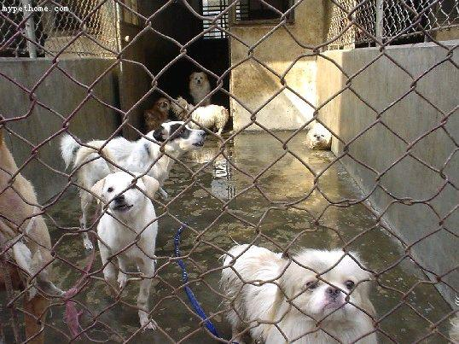

Each dog rush to eat the food we took to them, although it fell on the dirty water… This maybe is the last food before they go to the heaven…
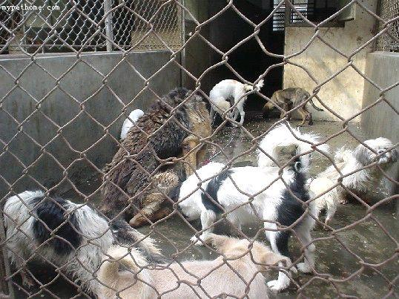
when you come to here…you will understand…die to here … what normal
Although it is useless, sunlight still fall on his little body… However, he got his freedom… the heaven he gone… no abandon, no starvation, no pain…
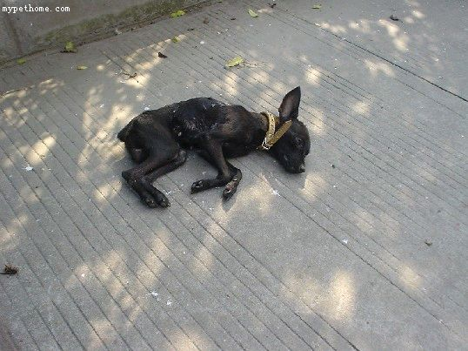
Can you see the hunger in their eye?
What we can do despite crying with them…Can we made this terrible thing to an end…
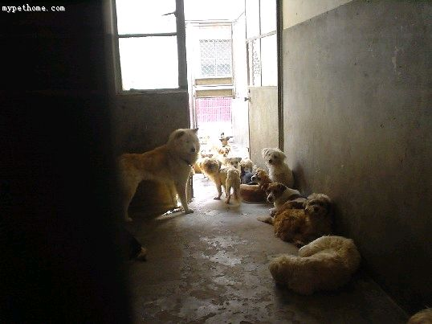
Do you see how they treat this dog…
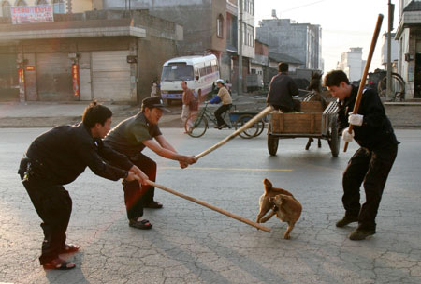

Chasing to kill…
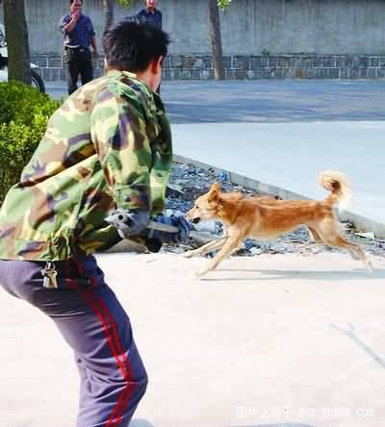

Slaughter!!!...
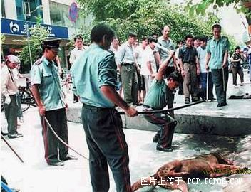

He gone… once he is the best friend of human… now we betray him…
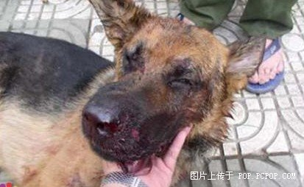

not only him, but also many many many other dogs…
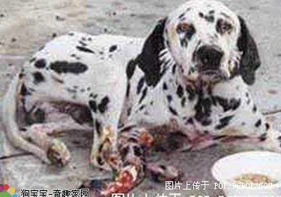
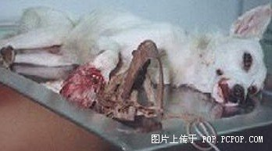

God dame who kill those dogs… I curse them too…
